**HACKATHON 2**

**M-D3030E**

**PANIC TWEETS PREDICTIVE MODELS**

**TEACHERS:** Sandra Mitrović, Stefano Toniolo

**STUDENTS:** Kaïs Boutaleb, Federico Panico,

Luca Testoni, Carlo Pezzotti

**CLASS:** D2A – I3A

**A.Y. 2023/2024**

**INTRODUCTION**

In this project, we embark on a journey to understand how humans and machines perceive panic in the fleeting whispers of the Twittersphere. We have amassed two sets of tweets, one expertly labeled by human minds and the other classified by a machine learning model. Both categorize tweets into three realms: person experiencing panic, general panic-related content, or unrelated to panic.

Our quest is to unveil the intricate dance between human intuition and machine learning in comprehending panic. We delve into the human perspective, exploring how annotators perceive and label panic across multiple rounds, seeking consistency and uncovering the unique characteristics of each classification. We then pit the machine against the human experts, comparing their performance and understanding.

But that's not all. We delve deeper, uncovering hidden patterns by analyzing features within the tweets themselves, searching for correlations with the assigned panic labels. We then step into the realm of unsupervised learning, using clustering algorithms to group tweets based on their content and annotations, uncovering potential thematic clusters. Finally, we build a predictive model, a machine learner trained to identify panic in unseen tweets, pushing the boundaries of automated understanding.

Through this comprehensive exploration, we aim to illuminate the human understanding of panic in tweets, assess the capabilities of machine learning in replicating this understanding, and potentially pave the way for better online crisis response and support for those experiencing panic attacks.

**DESCRIPTIVE ANALYSIS**

**(related to human annotation)**

* *Analysis of NoMajority labeled tweets*

The graph displays the distribution of human annotations for two rounds of classification on tweets related to panic.

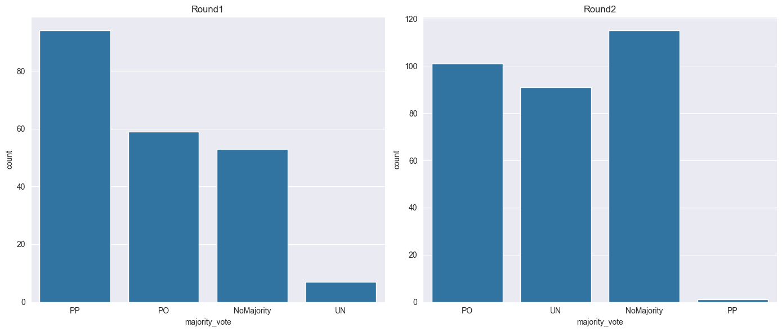

Key Observation:

* In the first round, "NoMajority" was the least frequent annotation, while in the second round, it was the most frequent. This suggests that tweets labeled "NoMajority" in the first round were revisited and reclassified in the second round, with a shift towards other categories (PO, UN, PP).

Potential Insights:

1. Difficulty in Classifying Ambiguity: The increase in "NoMajority" in the second round indicates that some tweets are inherently ambiguous or challenging to categorize within the defined classes (PP, PO, UN). This could be due to:
   * Subtlety of expression: Tweets might express panic indirectly or through nuanced language, making classification difficult.
   * Subjectivity of interpretation: The "panic" concept itself might be subjective, leading to differing interpretations among annotators.
   * Lack of context: Without additional information beyond the tweet content, it might be difficult to definitively classify panic.
2. Shifting Perspectives or Criteria: The change in "NoMajority" distribution between rounds could suggest:
   * Evolving understanding: Annotators might have refined their understanding of the classification criteria after more exposure to tweets, leading them to be more cautious about assigning specific labels.
   * Fatigue or bias: Repeatedly reviewing tweets could lead to fatigue or unconscious bias, impacting classification consistency.

Here we can notice that the NoMajority label it’s the most popular for the majority_vote column, leading with a 32.2%.

* *How consistent were the annotators between two rounds?*

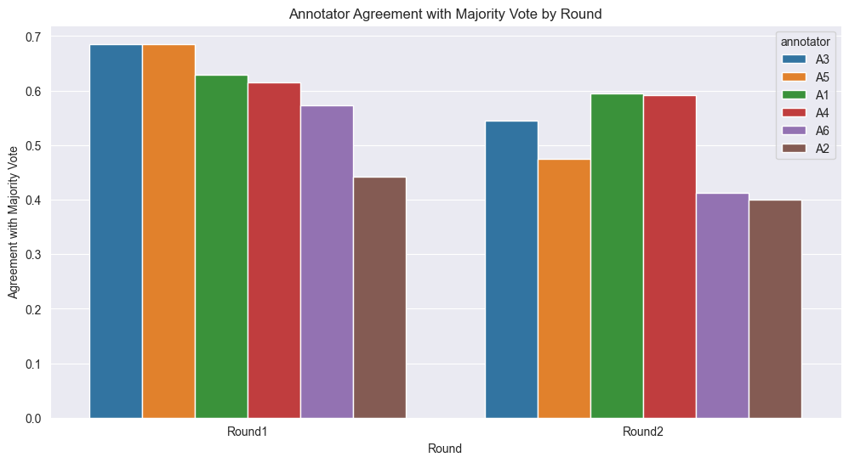

*roundID annotator agreement_with_majority*

*2 Round1 A3 0.685446*

*4 Round1 A5 0.685446*

*0 Round1 A1 0.629108*

*3 Round1 A4 0.615023*

*5 Round1 A6 0.572770*

*1 Round1 A2 0.441315*

*6 Round2 A1 0.594156*

*9 Round2 A4 0.590909*

*8 Round2 A3 0.545455*

*10 Round2 A5 0.474026*

*11 Round2 A6 0.412338*

*7 Round2 A2 0.399351*

* *What characterizes each class? Are there any correlations between features and labels?*

